CENWW-OD-EL 19 September 2017

MEMORANDUM FOR THE RECORD – 17 LWG 23 – MFR Spillway 1 Gate Seal Inspection.

SUBJECT: Spillway 1 gate seal damage inspection.

Spillway 1 gate seal was damaged June 19 during the removal of several logs wedged between the RSW and the spillway gate (photo 1&2). The RSW was closed at 1313 hours July 12 due to increased forebay water temperatures. Inspection of the seal requires the gate to be open 100% and was delayed until the RSW is re-opened for extended spill in support of Phase 1a. In the interim, as-built drawings and the tech section has been consulted by the mechanical crew to determine repairs and material needed to replace the missing section of the seal. The Project coordinated a 2-3 hour window the work week of September 18-21 to inspect the gate seal and verify the accuracy of the drawing. This information will be used to determine the materials needed to be ordered, time needed for materials to be delivered, develop a procedure and safety plan for work, and estimate of the total time needed for repairs. Spillway 1 gate seal was inspected from 1200-1352 hours September 19. During the inspection it was determined that about 20 feet of the seal is missing. To safely make seal repairs bulkheads will need to be installed in spillway 1. This will require the RSW to be tilted about 35 degrees in the upstream direction away from the spillway. Operations will need to monitor the RSW 24 hours/day to ensure damage to the RSW or spillway gate does not occur due to winds or river flows. Estimating the procurement time for materials and the time needed to perform repair work is ongoing due to the scope of the damage and unique access issues to the repair site. Following inspection the Project recommends ordering the required material/parts in preparation for repairs to begin after end of the 2018 spill season.

- Species – N/A
- Origin – N/A
- Length – N/A
- Marks and tags – N/A
- Marks and Injuries found on carcass – N/A
- Cause and Time of Death – N/A
- Future and Preventative Measures – N/A

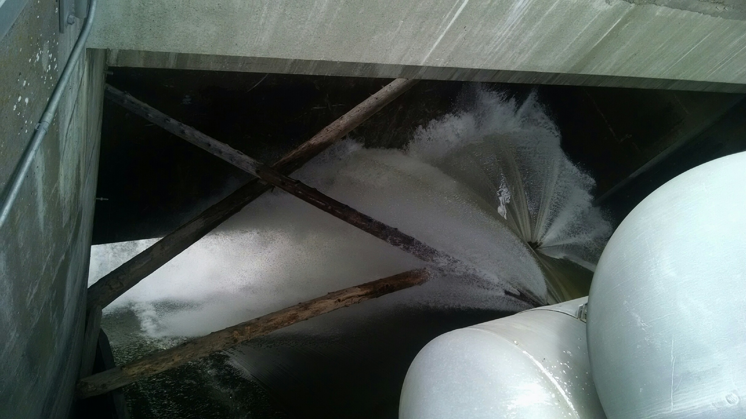
Photo 1. Logs wedged between RSW and spillways gate June 19, 2017.

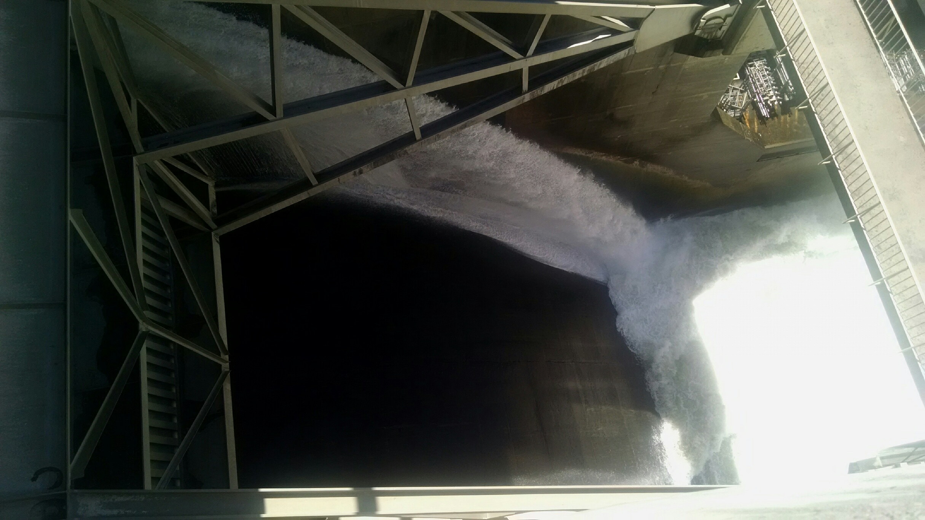
Photo 2. Spillway 1 seal leak while gate is in the closed position.

Sincerely,
Elizabeth Holdren
Supervisory Fisheries Biologist
Lower Granite Dam
Ph. 1(509)843-2263
Elizabeth.a.holdren@usace.army.mil

